**Project Part**: 4

**Date**: November 2nd, 2020

**Team Members**: Joseph Drahos, Rod Izadi

***Why do you need a separate thread for each client, and why can you not handle all clients in the main server thread?***

You need a separate thread for each client because each client need their own input and output streams. The SideClientServerIO streams handle receiving and echoing data for each client. The streams also must run concurrently because each stream waits for an input from the user. The main server thread would only be able to wait for a single client at a time, also the main server thread would not be able to handle inputs from more than one client at a time.

***Conceptually, why is the listener class ‘ClientSideServerListener’ different from the class ‘ServerSideClientIO’?***

The ClientSideServerListener is listening to the server and printing it to the client. That is its only job. A new ServerSideClientIO thread is made for every client added to the server and handles the inputs and outputs for that client to the server.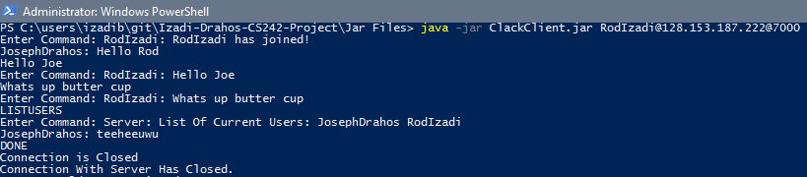

**Figure 1:** Client RodIzadi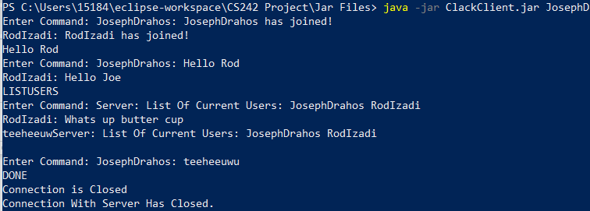

**Figure 2:** Client Joseph Drahos

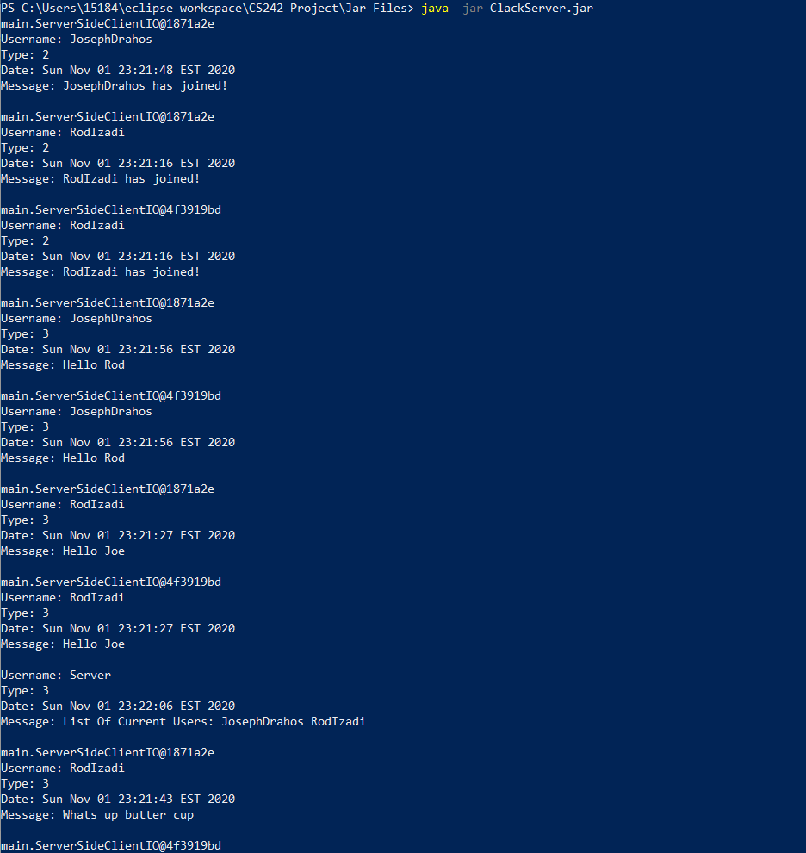

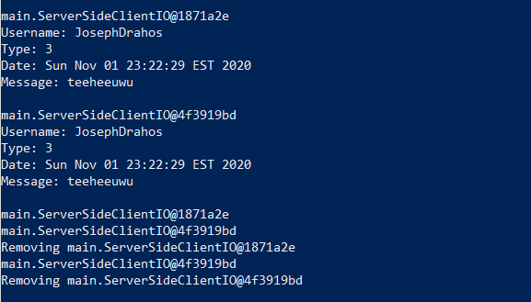

**Figure 3:** Server Side